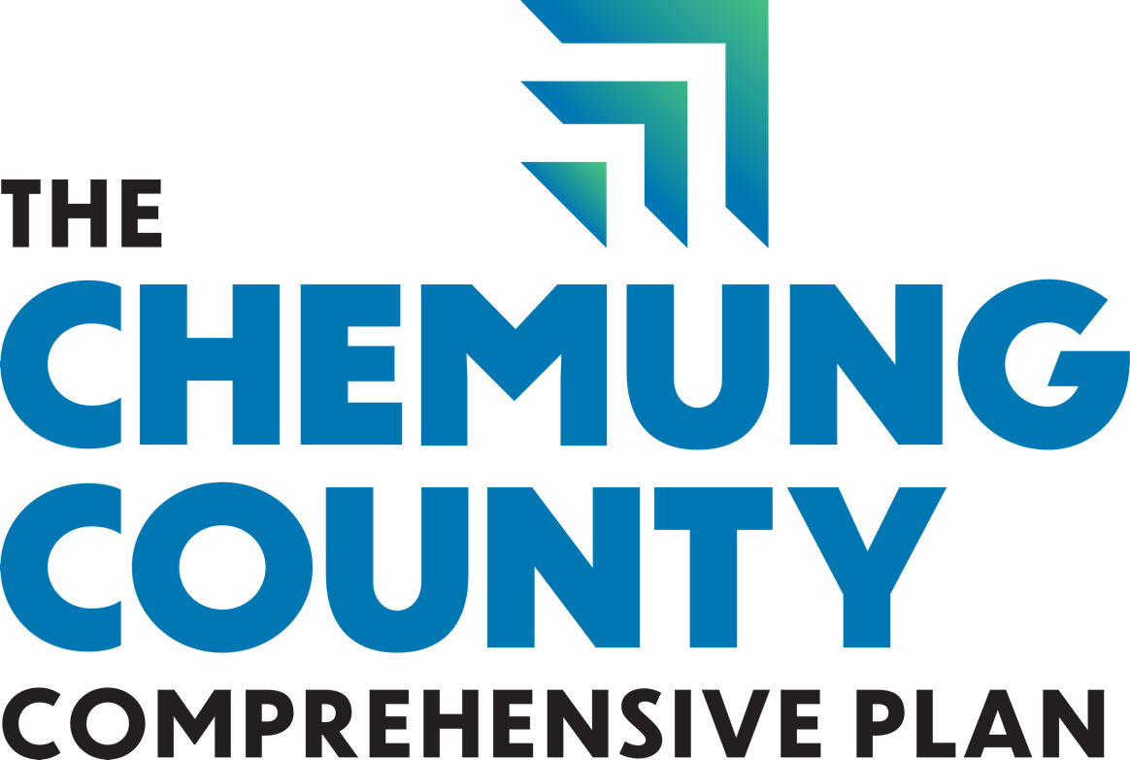

Public WORKSHOP # 2 Summary

Public Workshop #2 – Tuesday, September 17th, 2024, 5:00 PM – 7:00 PM
Arnot Event Center
Prepared by Highland Planning

Table of Contents
Workshop Overview: 1
Attendees: 2
Team In Attendance: 2
Themes and Priorities from Group Exercise 2
Appendix A: Presentation 8
Appendix B: Group Discussion Posters 10

Workshop Overview:

The consultant team's project manager, Frank Armento of Fisher Associates, welcomed the community to the public workshop and presented an overview of the three planning initiatives: the first-ever County Comprehensive Plan, Agricultural and Farmland Protection Plan, and update to the Long-Range Transportation Plan. Heike Jacob from Highland Planning then reviewed the public outreach activities conducted to date, including the first public workshop, two pop-ups, and an update on the community survey, which is ongoing. Frank Armento concluded the presentation by outlining the project schedule and next steps. The presentation is available in Appendix A.

After the presentation, participants talked in small groups to identify potential goals and objectives for the Comprehensive Plan. These group discussions concluded with each group sharing their ideas with all workshop participants.

Attendees:

Ten participants signed in at the workshop. Six participants attended the workshop virtually, including one who joined by phone.

First Name | Last Name | Organization
Dennis | Brown | Resident
Toby | Lagonegro | Resident
Michael | Perry | Elmira-Chemung Transportation Council
Andy | Avery | Chemung County DPW
Nan | Moss | Chemung County Planning Department
Dan | Panosian | Panosian Ent.
Jennifer | Furman | Chemung County
Roger | McCallum | Resident
Sheila | McCallum | Resident
Frank | Porter | EMC
Catheryne* | Chen
Craig* | Bond | Clemens Center
Andrea* | Ogunwumi | Economic Opportunity Program
Jim* | Siconolfi
Ashleigh* | Madison | IncubatorWorks

*denotes participant who attended virtually

Team In Attendance:

Frank Armento, AICP CEP, Manager, Planning Studio, Fisher Associates
Sarah Martin, Planner II, Fisher Associates
Megan Morsch, Public Engagement Lead, Highland Planning
Heike Jacob, AICP, Senior Planner, Highland Planning
Chris Moss, Chemung County Executive
Kevin Meindl, AICP, Commissioner of Planning, Chemung County & Director of ECTC
Alison Herman, Grants Manager, Chemung County Planning Department
Sean McGranaghan, Associate Planner, Chemung County Planning Department

Themes and Priorities from Group Exercise

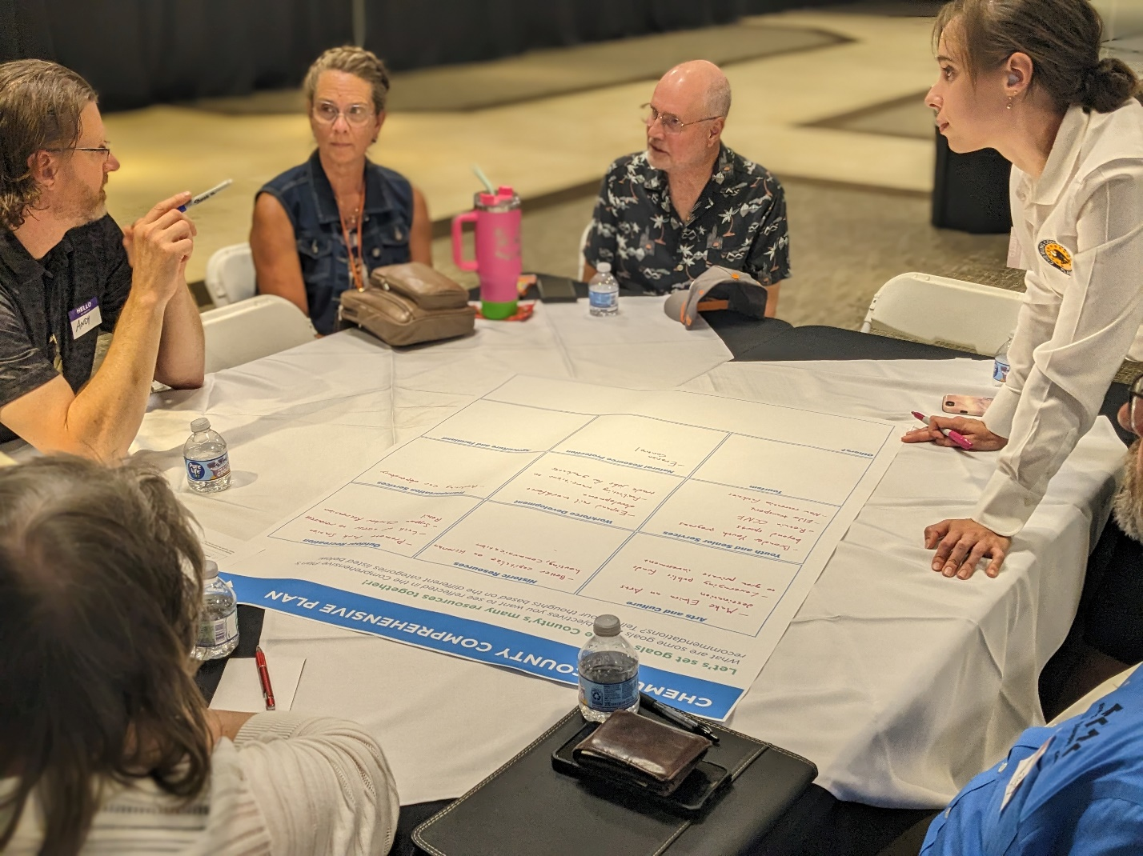
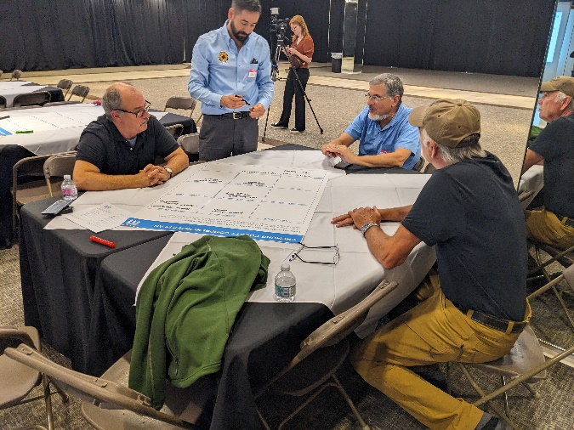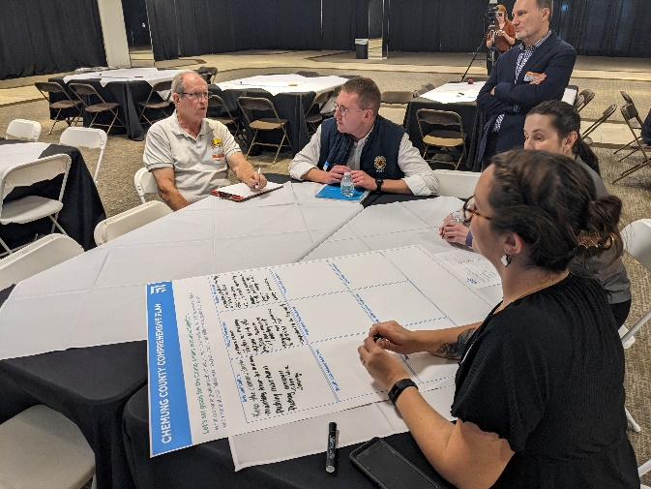

The workshop brought together community members to discuss various aspects of the County's future. The participants split into groups to discuss potential goals and objectives for the Comprehensive Plan for several categories, including: Arts and Culture, Historic Resources, Outdoor Recreation, Youth and Senior Services, Workforce Development, Transportation Services, Tourism, Natural Resource Protection, and Agriculture and Farmland. Participants were also given an option to add comments in an “Other” category for recommendations that did not fit into the categories listed above.

These discussions reflected a community deeply invested in its future, seeking to balance economic development with the preservation of natural and cultural resources while improving the quality of life for all residents.

Below is a summary of the responses:

Arts and Culture

The groups emphasized the importance of preserving and promoting existing cultural institutions while expanding the County's artistic offerings. One group highlighted the need to maintain the Clemens Center and Arnot Art museum and highlight the County’s Mark Twain heritage and aerospace history while emphasizing the fact that Chemung County is the soaring capital. Another group suggested making "Elmira a real arts-type destination with artist communities" while also noting the importance of "leveraging public funds to gain more private investment."

- Make Elmira an Arts destination
- Leverage public funds to grow private investment
- Keep the Clemens Center and the Arnot Art Museum well maintained and accessible to the public
- Promote Mark Twain and aerospace history
- Promote coordination between cultural institutions

Historic Resources

Preserving and capitalizing on the County's rich history was a common theme. One group suggested expanding "with the John Jones Museum, the Civil War Museum … [and] bring more awareness to historical rail." Another participant highlighted the potential historic value of the County’s Victorian housing, suggesting better communication with locals and tourists about these assets, reflecting: "Can you go to a webpage and click on it [a historic property] and find a picture of it with a little bit of history on it? I can't. So, I think that would be a great way to really show” the County’s historic built environment.

- Better capitalize on Victorian housing (find a way to inventory and share that inventory)
- Promote Mark Twain's history
- Invest in historical museums such as the John Jones Museum and Civil War Museum
- Bring more awareness to historical rail
- Co-advertise with outdoor recreation opportunities

Outdoor Recreation

Participants recognized the County's natural assets as a key draw for both residents and tourists. One group proposed "expanding, taking advantage of what we have, emphasizing our green space, expanding the rails to trails network, investing in the outdoors and encouraging industries to come here because of our outdoor resources." Another participant suggested expanding Park Station with additional hookups, as space is currently limited to 40 camping slots and is often fully booked.

- Support Tanglewood and Sullivan's monument
- Expand the Rails to Trails network
- Protect green space, especially County/local parks, and expand parkland where possible
- Market outdoor recreation opportunities to potential employers to highlight relocation benefits/local amenities
- Improve pedestrian/bicyclist access to trails, parks, etc.
- Expand Park Station Campground
- Support outdoor recreation retail

Youth and Senior Services

Participants emphasized the need for comprehensive services for both young and old residents. For seniors, one group suggested that expanding senior services helps with “keeping people in their homes, connecting residents to state and [County] [re]sources available, and … having the liaisons who will help residents apply for those services." They proposed "mentorships that would keep the youth invested in the community and encourage them to stay here." Another group stressed the importance of "broadening youth programs beyond sports."

- Develop youth programs in addition to sports programs (arts, drama, music, etc.)
- Retain Chemung County Nursing Facility (CCNF)
- Increase staff resources for the Office of Aging
- Create mentorship programs for youth
- Expand senior services to allow seniors to age in place
- Connect residents to state resources for the elderly
- Expand quality childcare options
- Promote diversity in youth and senior services
- Create youth activity centers
- Support the Chamber of Commerce leadership program

Workforce Development

The participants recognized the importance of preparing the local workforce for future opportunities. One group suggested implementing "shadowing programs” such as BOCES, focusing on technical education, "expanding public private partnerships,” and “encouraging young kids to learn their options, whether they want to go to a trade or higher ed." Another participant highlighted a recent development: "The big announcement last week was Siemens coming in with 300 good paying jobs to build the highest speed train …in the US. …[W]e need to have the workforce development for those real jobs."

- Implement shadowing programs
- Expand BOCES technical education
- Encourage public-private partnerships
- Promote various career paths to youth (trades as well as higher education)
- Consider tuition assistance for adult education
- Capitalize on remote work opportunities
- Encourage more high-paying jobs
- Provide training opportunities and leadership programs
- Increase summer and school internships for high school students that lead to employment
- Increase funding for child care for second and third shift workers

Transportation Services

Improving transportation options was seen as crucial for the County's development. One group proposed to "expand transportation. Make sure that [the transportation system is] safe and reliable and accessible for seniors. Expand bike and trail options." Another group emphasized the need to reduce car dependency, suggesting the County construct park and ride lots and implement complete streets.

- Expand transportation options and reduce car dependency
- Build park and ride lots
- Ensure safe, reliable, and accessible transportation for seniors
- Expand bicycle infrastructure and trails, particularly in suburban and rural areas
- Implement Complete Streets
- Educate bicyclists on the rules of the road
- Regulate electric bikes and scooters (dangerous for pedestrians if riding on the sidewalk)
- Increase transportation options for local and cross county travel (i.e. Ithaca, Binghamton)

Tourism

The participants saw potential in boosting tourism by leveraging local assets and collaborating with neighboring areas. One group suggested "increased awareness and marketing of the assets that we have here in the community” and capitalizing on the County’s proximity between Toronto and New York City. The participants also proposed "tourism crawls [in partnership with] other surrounding counties. Go to Watkins Glen, Elmira, Corning."

- Increase awareness and marketing of local assets, especially unique assets (e.g., Park Carousel)
- Advertise Elmira as a destination between Toronto and NYC
- Collaborate with surrounding counties for tourism initiatives (draw traffic from Corning Museum of Glass, Watkins Glen, etc.)
- Expand on Mark Twain's brand
- Promote local restaurants, farms, wineries, and breweries
- Develop cohesive branding for attractions
- Develop downtowns (villages, hamlets, etc.) and create a sense of place

Natural Resource Protection

The participants expressed strong interest in protecting Chemung County's natural resources while balancing development needs. One group emphasized the need to "protect our natural resources, increase land trusts, protect waters, lakes, rivers," and suggested incentives for revitalizing vacant city lots to prevent sprawl. Participants also discussed the importance of sustainable growth, proposing cluster development to preserve open land. Erosion control emerged as a concern, with one participant noting, "Our storms are greater, more frequent. Anybody that is fortunate enough to live near a creek has also has the misfortune of losing their property from time to time." This led to discussions about improving infrastructure resilience. Planting urban trees was also highlighted as crucial, especially in the County's urban core where tree cover is more sparse.

- Protect natural resources, especially lakes, rivers, and other bodies of water
- Increase land trusts and protect open/green space
- Limit sprawl by encouraging adaptive reuse, development on vacant land already in developed areas, and cluster development
- Implement erosion control measures
- Increase urban tree planting
- Plan for resiliency for critical infrastructure such as roads and bridges (e.g., in response to flooding issues)
- Address challenges from mineral extraction industries (i.e. gravel mining)

Agriculture and Farmland

Preserving and sustainably using agricultural land emerged as a key topic, with participants expressing concerns about the changing farming landscape and economic pressures on farmers. A major point of discussion was the impact of renewable energy projects on farmland, with one participant questioning, "Was the best use of that farmland really to put solar and wind projects on, particularly when it's our best viable farmland throughout the county?" Acknowledging that "farming is not making money," the group explored potential solutions. One suggestion was to help farmers diversify through specialty farming, as "Farms aren't going to compete in our County with large-scale dairy farms. It just can't happen. So different kinds of specialty farms could be a way to help farmers stay in the industry that they love but still make a living at it." These discussions highlighted the community's desire to balance agricultural heritage, economic viability for farmers, and broader needs for food production and renewable energy.

- Promote specialty farming
- Address impact of solar and wind projects on farmland

Other

- Ensure access to quality healthcare for all by bringing specialists to the community instead of having to drive to Rochester
- Look at other communities and what has worked there (follow best practices)
- Some goals/objectives are interconnected and should be treated as such
- Improve outreach and communication from the County to residents
- Increase options for Internet service providers
- Support and provide resources to towns outside the urban areas who may be struggling
- Increase retail stores in the City of Elmira
- Increase funding and supportive care services to address the needs of the homeless population
- Consider public private partnerships to create a sense of community wellbeing and encourage residents to stay in the county and help it grow and flourish

Appendix A: Presentation

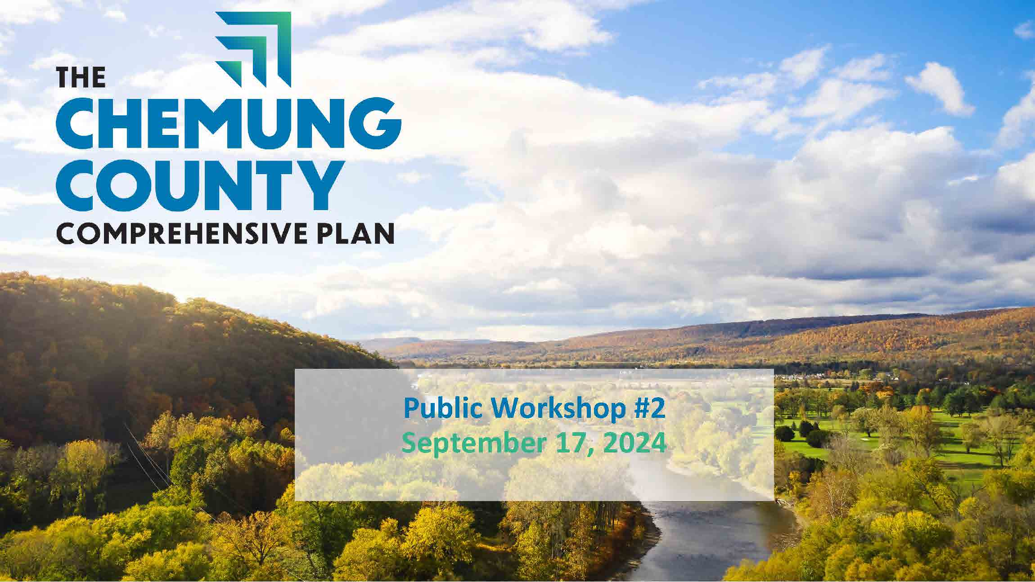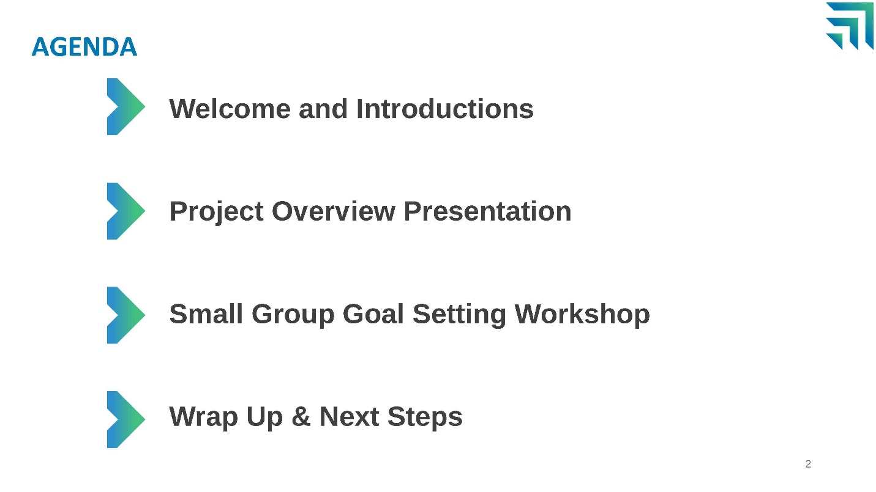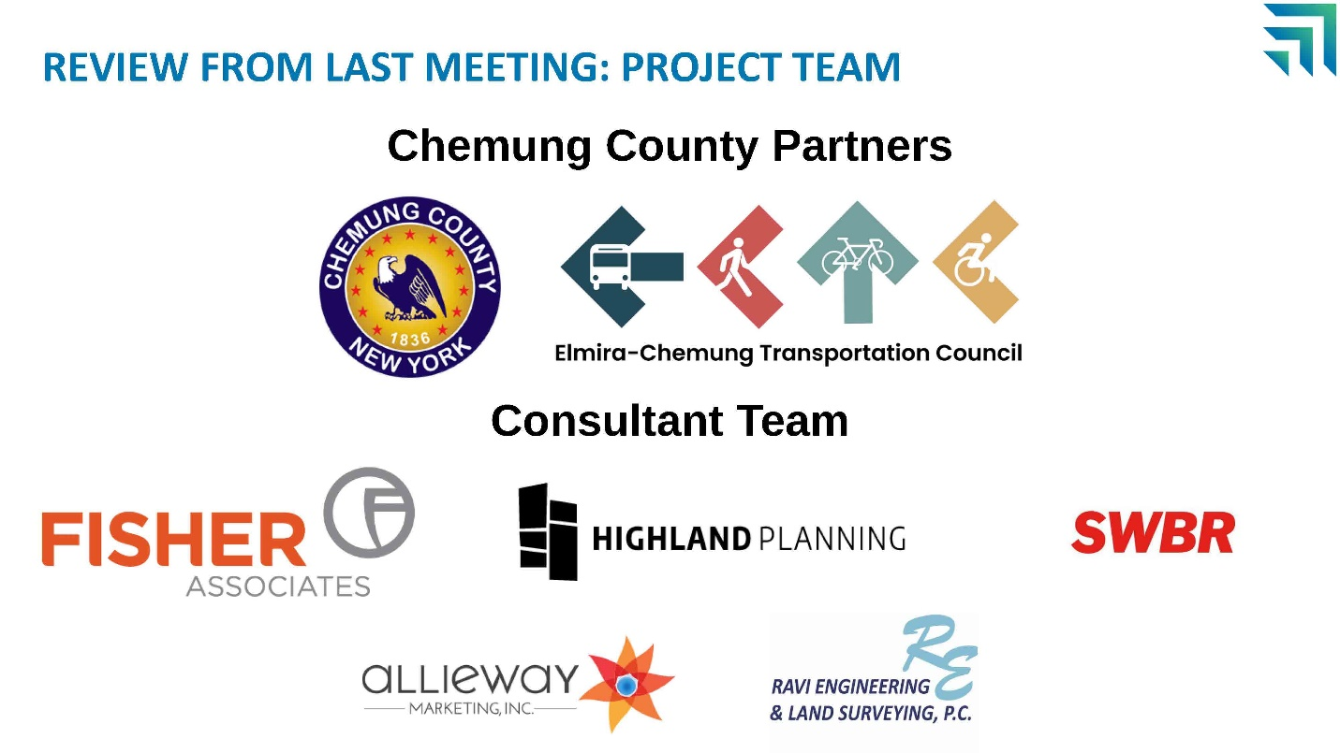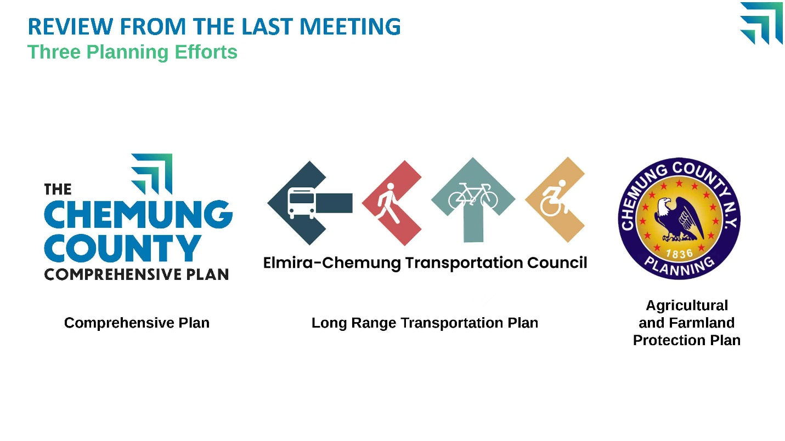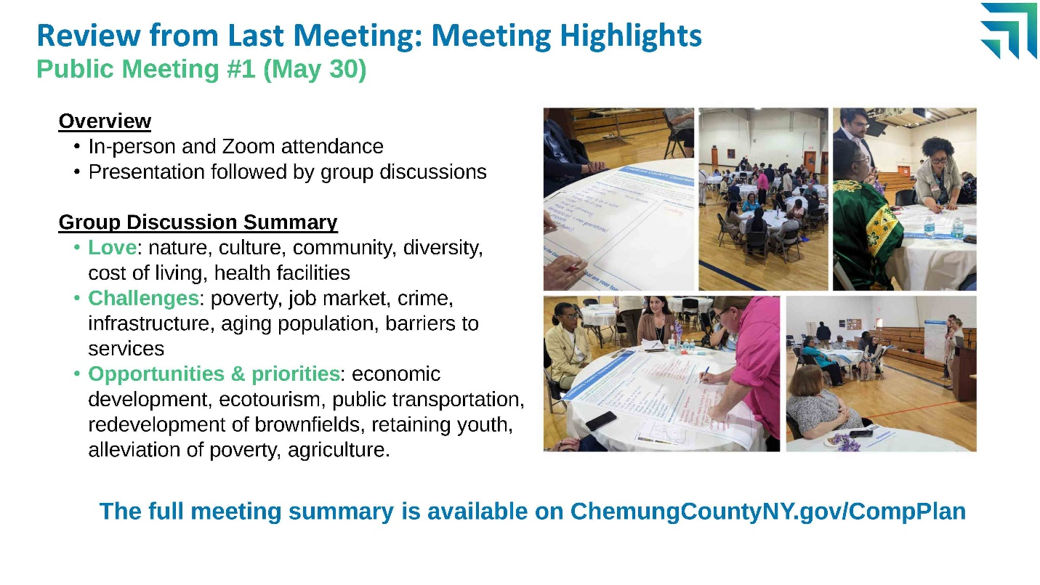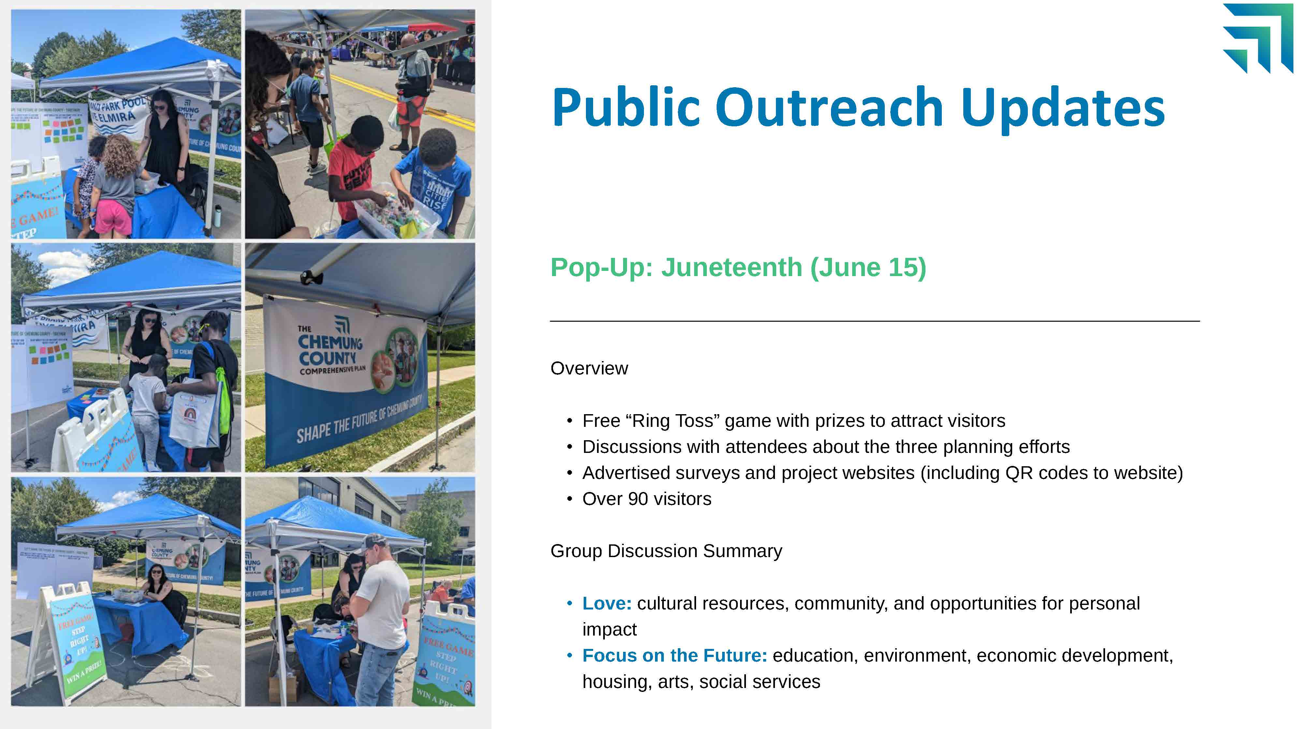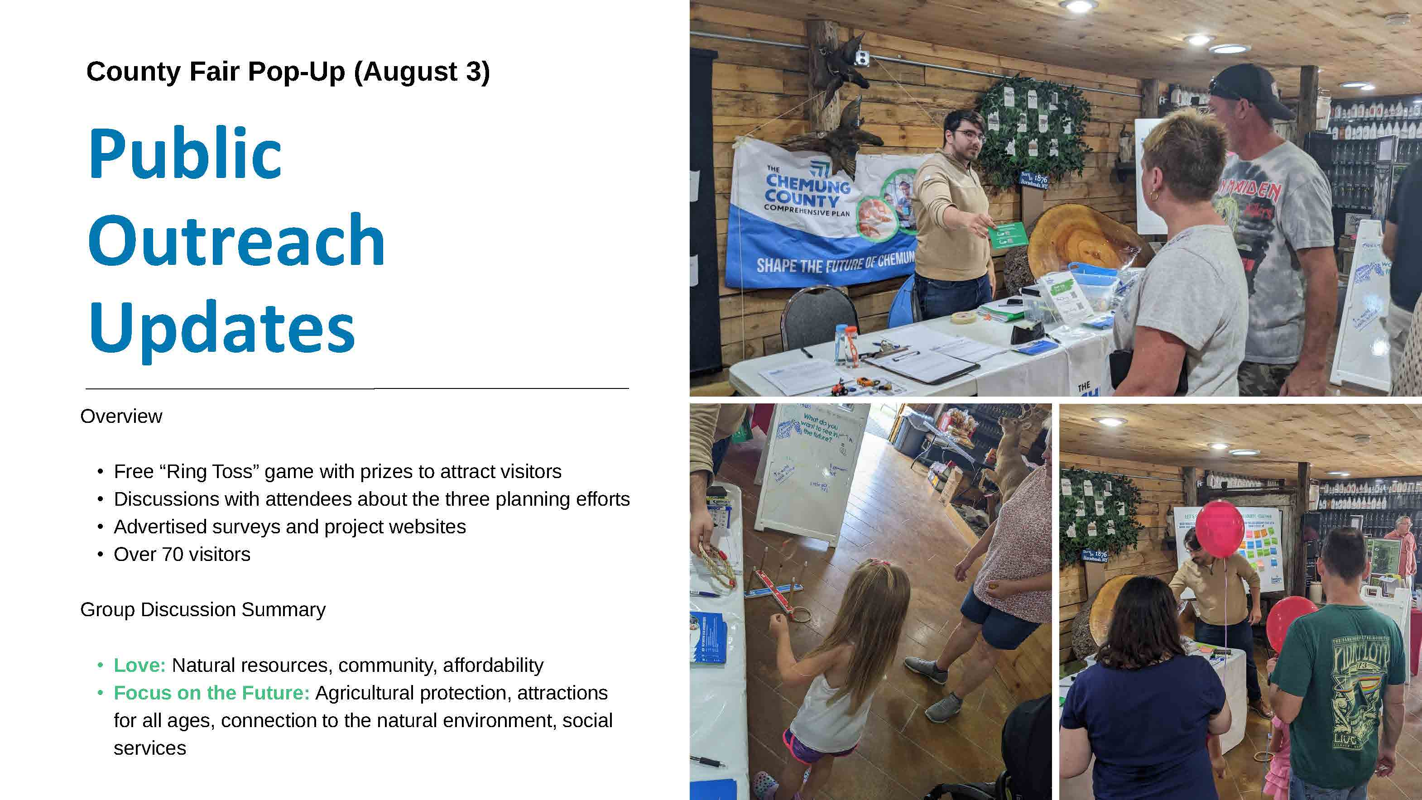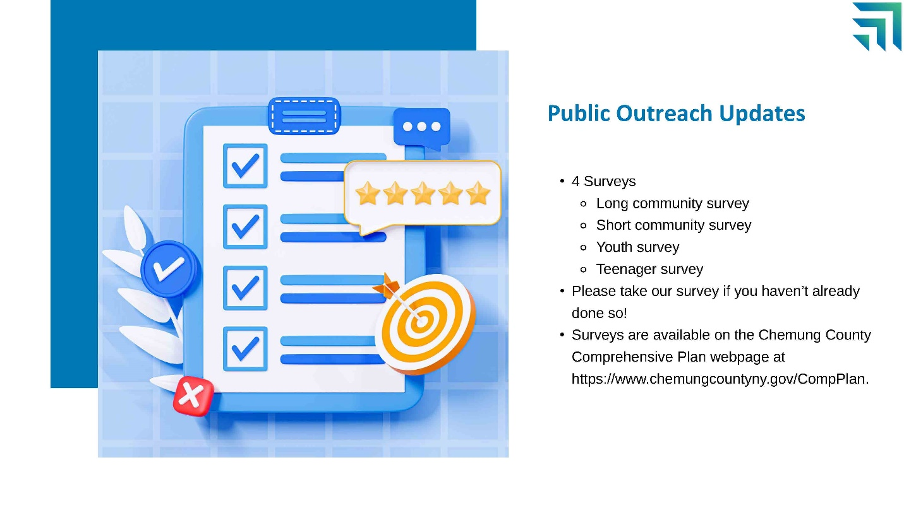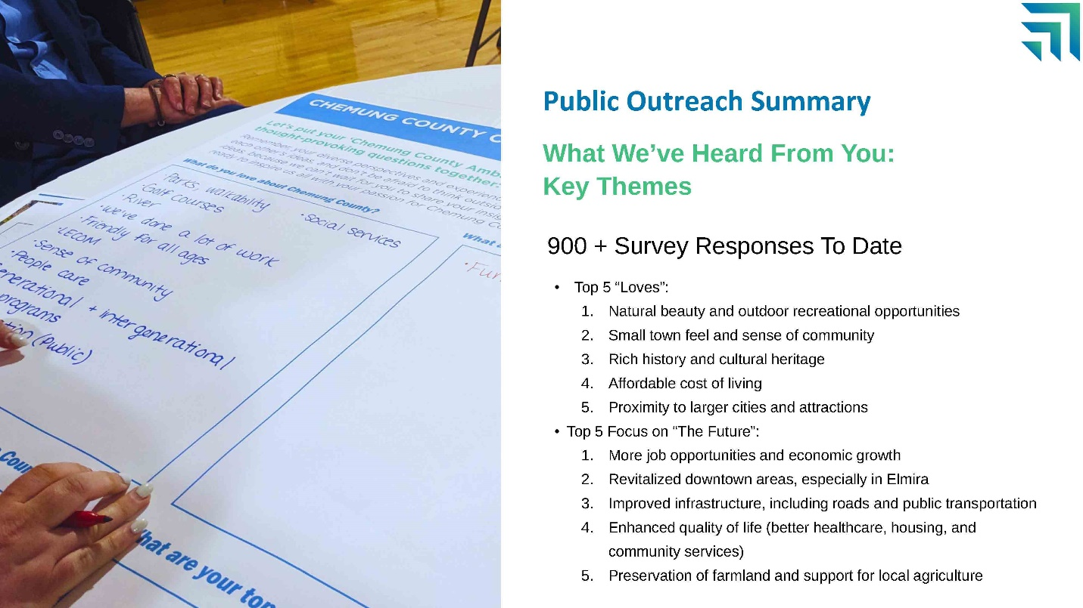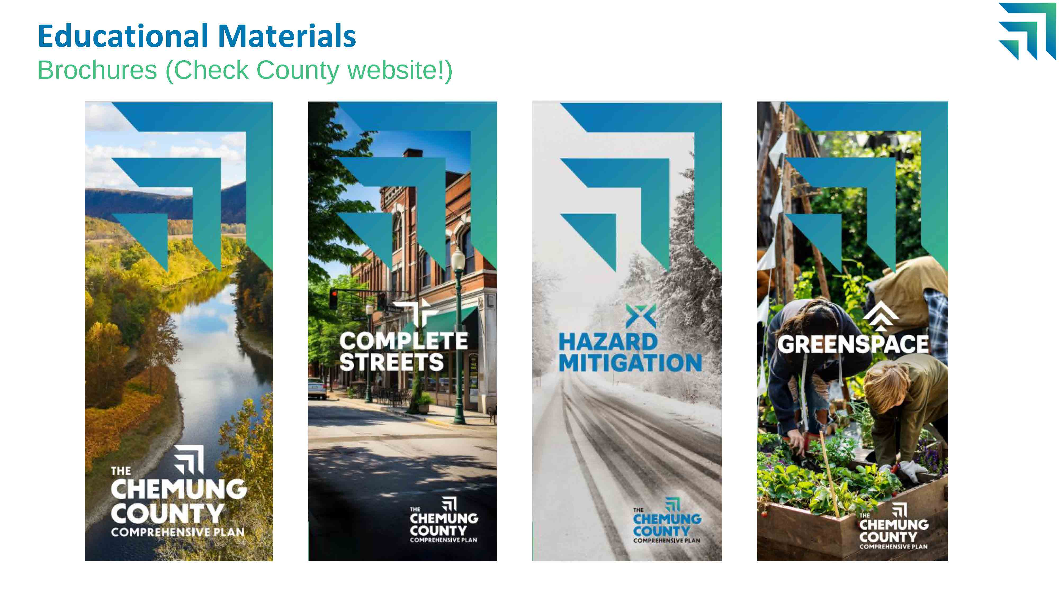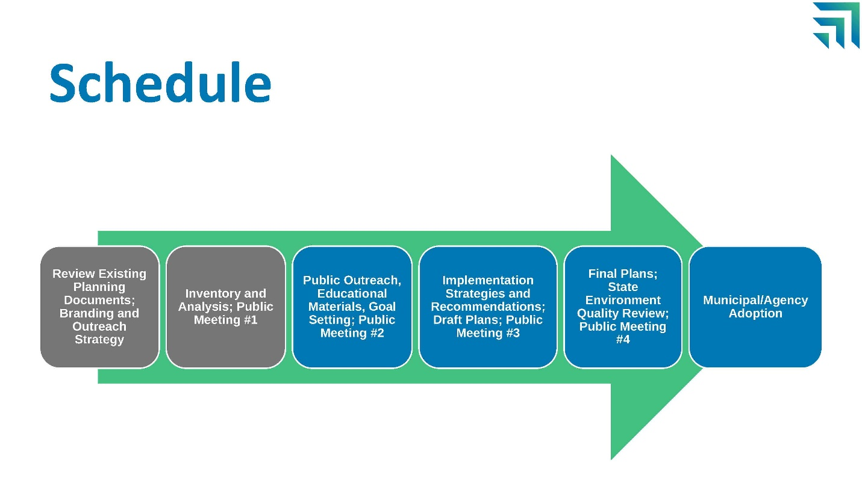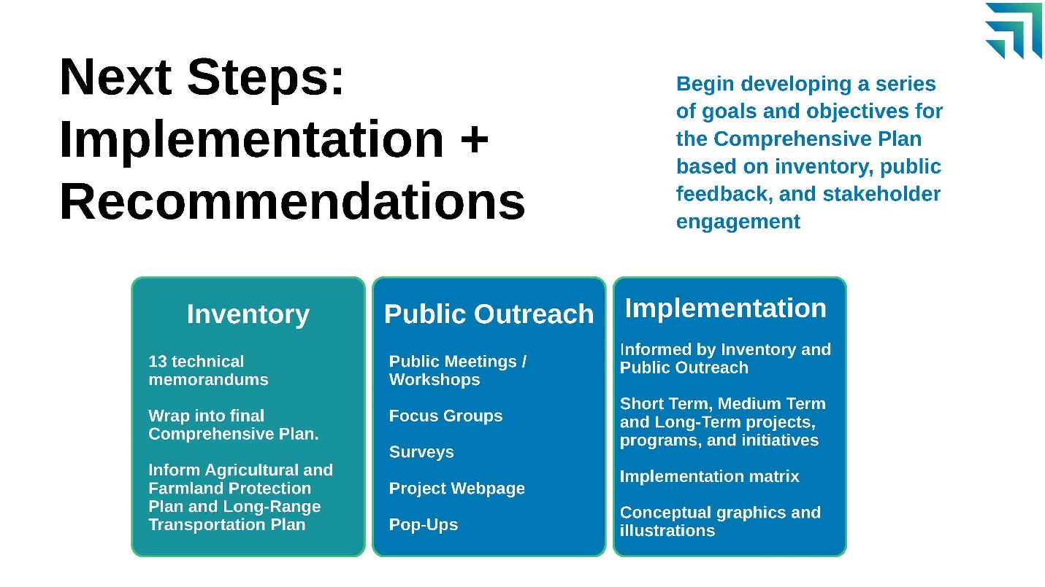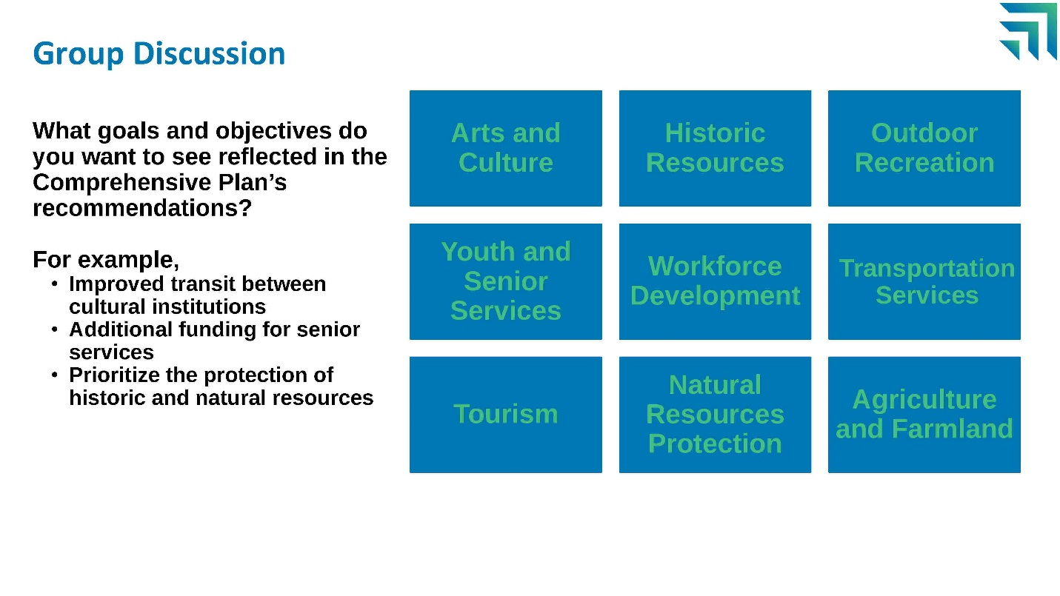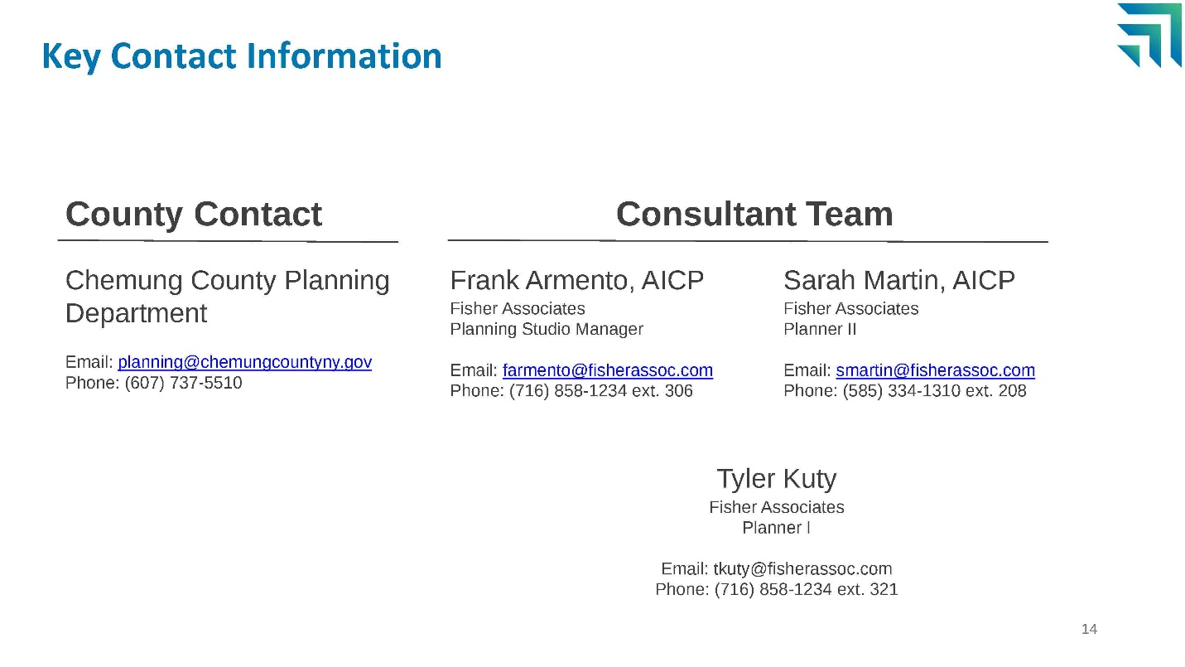

Appendix B: Group Discussion Posters

